Process logic for approving a new access point for PEPPOL Authority
The service provider is initiating this process with sending an apply for membership in OpenPEPPOL. OpenPEPPOL Operating Office will handle the apply and give response to the service provider.
When PEPPOL Authority receive the PEPPOL Transport Agreement and the company registration, the authority must check all documentation. If the received documentation is not correct, the service provider must resend the documentation and the PEPPOL Authority stops the process.
If the received documentation is correct, the PEPPOL Authority send a message to the Certificate Authority with the Agreement, Annex 1 and company registration form. The Certificate Authority will send a message to the service provider with attachment on how to activate the pilot certificate if all information is correct. If the received information is not correct, the PEPPOL authority will get information from the Certificate Authority.
When the service provider is finished tested, PEPPOL Authority will receive a test form from the service provider. The PEPPOL Authority will check the test form and give the Certificate Authority instructions to issue a production certificate to the service provider if the test is ok, if not the service provider must retest.

Overview all parts involved
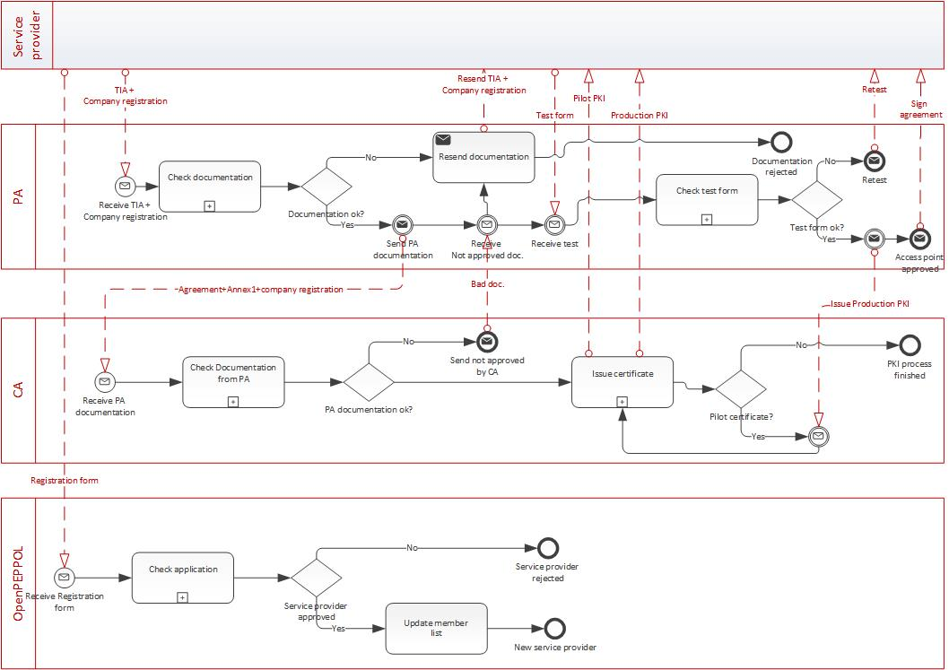

Check received documentation from service provider
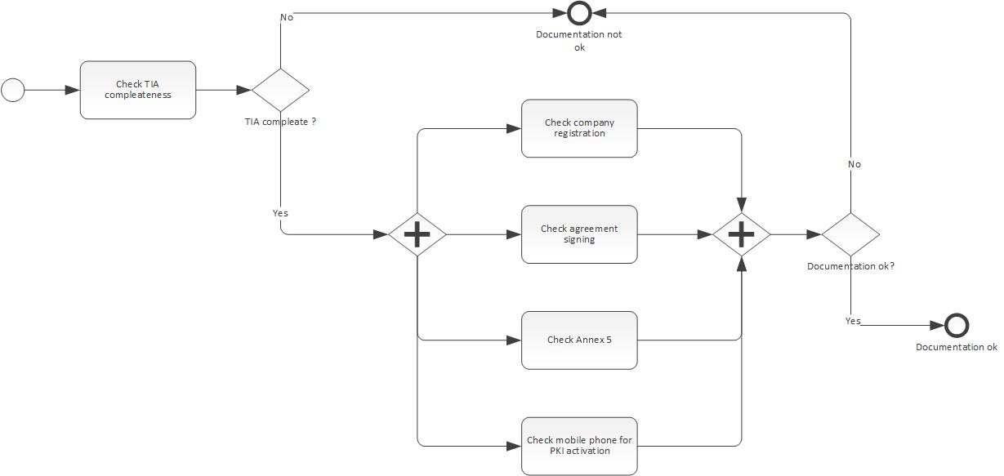
The first check if the PEPPOL TIA is complete and if so the PEPPOL Authority need to consider the details. The details are:
Company registration:
The PEPPOL Authority must ensure that the service provider is an actual company and
Agreement signing:
The agreement must be sign. The person signing the agreement must have the rights to do so. The PA must ensure that the agreement is complete and not missing any parts.
Annex 5:
Annex 5 must always be sign. The Annex5 is giving instructions to the service provider to make transactions reports, which documents to handle and other important thing Norway need as PEPPOL Authority.
Mobile number in Annex 1:
Annex 1 agreement point 4.6 must contain a mobile number and the phone number must belong to the correct person stated in point 4.6.

Check received test documentation

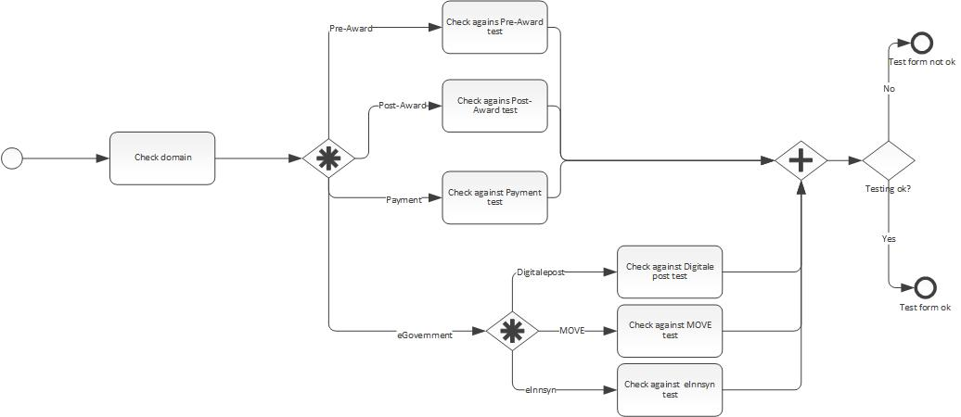

This sub-process start with determined which domain the service provider belonging to. There are four main domains, Pre-Award, Post-Award, Payment and eGovernment.

PA must evaluate the test schemas regarding to which domain the test is denoted for.

