OpenPEPPOL Testbed
Implementation proposal for established requirements

Last updated 6. June 2018

OpenPEPPOL AISBL
Rond-point Schuman 6, box 5
1040 Brussels Belgium

Document Logistic
This document covers background information for established requirements and an implementation proposal for the solution.
Submitted on request from Deputy Secretary General Anna-Lis Berg.
Revision History
Date of this revision: 06.06.2018 |  |  | Date of next revision
NR | Date | Summary of Changes |  | Changes marked
0.1 | 05.05.2018 | First draft |  | (N)
0.2 | 06.06.2018 | Second draft |  | (N)
 |  |  |  | (N)
Approvals
There is no need for formal approval of this document in advance. As it is made as a background document for decision making in the relevant decision body of OpenPEPPOL.
Approvals resulting from this request should be noted in an appendix to this document and included in the minutes of the meeting in which this document was discussed.
Owner, Editor and Contributors
Submitted by: OpenPEPPOL Operations:
Unit | OpenPEPPOL Operations (Operational Office)
Owner | Anna-Lis Berg (former Deputy Secretary General & D2D manager)
Editor | Mikael Aksamit, advisor & technical lead
Contributors | Mikael Aksamit, advisor & technical lead  Anna-Lis Berg Project manager
Distribution
Distributed to TICC CMB
Hans Berg | Leader of TICC
Phillip Helger | TICC CMB member
Risto Collanus | TICC CMB member
Bard Langoy | TICC CMB member
Olav Kristiansen | TICC CMB member

Table of Contents
1. Introduction 3

1.1. Issues raised 3

1.2. Purpose 3

1.3. Decision needed 3
2. Background information 4
3. The high-level strategy for implementing a centralized testbed 5

3.1. Roles and responsibility 6
4. the requirements for implementing the centralized Test Bed 7
5. the testcase covered by the first version of the test bed 7
6. Solution Outline 8

6.1. Proposed Solution 8

6.1.1. Open Strategy 9

6.1.2. Technical Overview 9
Figure 1 - Layers of the testbed and orchestration with arbitrary AP implementations 9

6.1.3. REST API 10
7. the next step in the process 10
8. Additional notes 11

- Introduction
This document describes the agreed terms and conditions for implementing a centralized e-delivery Testbed in OpenPEPPOL, as the document lays out the overall requirement, an implementation strategy agreed by the appointed representatives from TICC and Operations during H2 2017 & H1 2018 as well as the solution outline made by the appointed implementation taskforce based upon these agreements.
  - Issues raised
The main issue raised in this document is how to ensure that the centralized Testbed is implemented in a flexible, scalable, user-friendly, cost efficient and PEPPOL compliant way.
  - Purpose
The primary purpose of this document is to lay out the discussed baseline for implementing the first version of the Centralized Testbed in a clear and unambiguous way, enabling the TICC CMB to verify the discussed terms and conditions and approve the suggested solution outline.
  - Decision needed
The TICC CMB needs to approve
- The high-level strategy for implementing a centralized Testbed
- the requirements for implementing the centralized Testbed
- the testcases covered by the first version of the Testbed
- the solution-outline
- the next steps in the process
Should the TICC CMB not be able to approve the current version of terms and conditions it is highly recommendable to agree of alteration of these at a TICC CMB meeting, as a rapid implementation of the Testbed is important for several ongoing OpenPEPPOL activities.

- Background information
During 2017 it became evident that OpenPEPPOL need to improve, align and quality assure the onboarding of Service providers, as the onboarding process has been complicated and cumbersome due to growth and increased complexity:
- An increased number of PEPPOL Authorities have started to impose individual test strategies.
This not only makes it difficult for Service Providers to join the PEPPOL network and for OpenPEPPOL operations to guide the Service Providers during onboarding, it also is in breach with the overall OpenPEPPOL principle of “Connect once reach all”.
- The growth of OpenPEPPOL resulted in the need for On-demand support and access to the test-facilities. A demand that could not be catered for as long as the test facility and support was provided by in-kind resources without allocated time.
- The use of a national test facility for global testing increasingly confuses new Service Providers joining OpenPEPPOL as they are likely to have less knowledge about the nature of the association and the network as the Service Providers joining in the past.
- The introduction of a tentatively new e-delivery transport protocol has created the need for expanding the current test capability to include also the AS4 profile, and showed the future need to provide self-test facilities for Service Providers prior to the formalistic onboarding test.
A number of Activities was put in place to mitigate the situation:
- H2 2017
  - The Transport Infrastructure Coordinating Community decided to establish a work group to handle these issues.
  - OpenPEPPOL operations investigated the operational aspects of taking over the test responsibility from Difi Norway.
  - The OpenPEPPOL Managing Committee was defining a revised managerial setup of the Association, moving responsibility for implementation and operations of PEPPOL network elements and artefacts from the member communities to Operations and 3rd party vendors.
- Q4 2017
  - Collaboration between TICC CMB and OpenPEPPOL Operations is established in order to cater for the decided move of operational responsibility, discussing requirements, terms and conditions for the elements handed over (PKI- test bed and PEPPOL directory).
  - Discussions regarding terms and conditions for implementation and operation of the e-delivery elements were initiated.
- January 2018
  - (During the Managing Committee meeting in Rome) the MC agreed that OpenPEPPOL Operations was ready to take over the full responsibility for implementing a centralized Testbed (version 1.0) and to deploy it for production.
  - At the same time, the Managing Committee asked the Deputy Secretary General and the TICC Leader to work closely together in order to define and implement collaboration processes covering the handover and future collaboration round the PEPPOL e-delivery elements.
  - It was agreed that TICC CMB should continue to define functional and non-functional requirements, and raising change requests to Operations, but that Operations was responsible for defining, designing and implementing the requested changed.
  - It was agreed that Operations would seek TICC CMB approval for solution design and implementation plans to ensure that the implemented elements were not in breach with community related strategies or policies.
- February 2018
  - Operations established a Testbed implementation project and started consolidating and documenting requirements for implementation of Testbed functionality.
  - The mandate of the TICC test requirement Workgroup established under TICC was formally approved by TICC CMB on 9th February 2018

- March – June 2018
  - Testbed implementation project established under operations had a workshop with the CEF team to evaluate the additional requirement needed in order also to cover AS4 implementation. (0.04.2018 -10.04-2018 in Brussels)
  - Operational Office changed operational structure and management.
  - The Testbed implementation project focused on solution design and documentation, to prepare for final TICC CMB approval

- The high-level strategy for implementing a centralized Testbed
OpenPEPPOL will implement a centralized Testbed providing self-service testing to service providers implementing PEPPOL specifications. This Testbed will (over time) cover test facility for e-delivery onboarding test, SMP onboarding test and BIS document validation.
This Testbed will be implemented in iterative steps beginning with the V 1.0 of the e-delivery test functionality. (see implementation strategy below)
The first version of the centralized Testbed will cover e-delivery test only and will be implemented by Operations according to guidelines provided by a test bed workgroup established under the jurisdiction of TICC.
The baseline for implementing v1.0 of the e-delivery Testbed is a tailored subset of the current test setup provided by DIFI Norway, including only e-delivery specific part of the test and tailored according to recommendations and requirements provided by TICC and TICC CMB members.
Version 1.0 of the e-delivery Testbed is up for approval in this document. Future versions will be put up for approval in the TICC CMB when defined, designed and documented by operations.
The expected iterative steps in implementation are as follows:
- Implementation of a e-delivery Testbed functionality V 1.0 for AP using the OpenPEPPOL AS2 profile (in scope of this approval)
- Implementation of a e-delivery Testbed functionality V 1.0 for AP using the OpenPEPPOL AS4 profile (in scope of this approval)
- Expansion of underlying AP test implementation with AP’s based on other technologies (in scope for this approval)

Future functionality/ implementation is out of Scope for this approval:
- Implementation of a e-delivery Testbed functionality V 2.0 including a pre-test playground for AS4 implementers (out of scope)
- Implementation of Centralized SMP test facilities (out of scope)
- Implementation of BIS document validation services (self-test) based on Schematron validation (out of scope)
- Implementation of additional validation services (self-test) (out of scope)
- Ongoing maintenance and further development (out of scope)

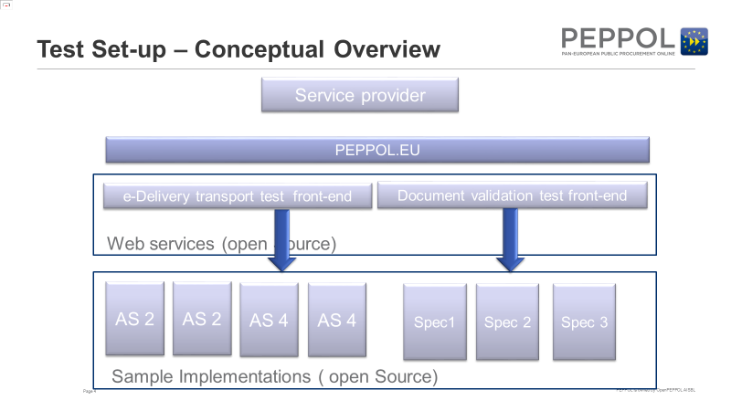
  - Roles and responsibility
OpenPEPPOL Operations is responsible for handling implementation, operation and support of a centralized Testbed (version 1.0).
The eDelivery work group is responsible for defining requirements and recommendations for improvement, in order for Operations to implement those as plan of the D2D implementation activities.
OpenPEPPOL Operations is responsibility for obtaining approval from the relevant CMB’s when implementing or changing test functionality:
- AP test solutions are to be approved by the TICC CMB
- SMP test solutions are to be approved by the TICC CMB
- BIS document validation is to be based on existing Schematron rules, and approved by the relevant CMB in the respective community.
The TICC CMB is responsible for evaluating, approving or rejecting solution design presented by Operations
- the requirements for implementing the centralized Testbed
In scope for Version 1.0
- Testbed covers listed test cases and operates with a minimum of manual intervention
- Ability to verify compliance on a technical level in terms of the AS2/AS4-protocols and specifications
- Implemented as a web-based application with a self-service user interface
- The Testbed is operated and supported by OpenPEPPOL operations
- The Testbed is being hosted and maintained by a 3rd party in a generic setup (provider) and implemented in a way to ensure minimal maintenance activities – SLA agreement is mandatory
- Provide efficient and scalable service provider on-boarding
- The testbed is an accessible tool for service providers during implementation phase (of OpenPEPPOL specifications)
- The Testbed should enable to interact with different AP implementation as backbone AP
- The Testbed should produce a report with the result of executed test cases and which Testbed AP implementations were tested with.
- Testbed implementation strategy should cater for scalability in scope and functionality

Out of scope for version 1.0
- BIS document and content conformance
- Hosting of 3rd party backbone AP implementations are not considered as part of the Testbed operation
- Local or regional requirements mandated by OpenPEPPOL Authorities.
- SMP onboarding test
- AP Implementation Playground

- Test cases covered by Testbed v1.0
The first version (1.0) of the Testbed will cover the following use cases (utilising an Oxalis AS2 implementation);
- Testbed (TB) AP (Oxalis AS2) sends a valid document to service provider (SP) AP using a valid certificate (should pass)
- TB AP sends an empty document to SP AP (should fail)
- TB AP sends a valid large (50 MB+) document to SP AP (should pass)
- TB AP sends a valid document to SP AP using an invalid certificate (should fail)
- Step 1 to 4 are repeated for alternate AP implementations (TB will support this functionality out of the box but won't be enabled in version 1.0 since no other AP implementations will be integrated)
- SP AP sends a valid document to TB (Oxalis AS2) using a valid certificate
- SP AP is requested to send valid documents to TB AP (for available alternate AP implementations)
- SP AP requested to send to TB AP that uses an expired certificate in SMP response (transaction should never be initiated)
- SP AP requested to send to TB AP that uses a revoked certificate in SMP response (transaction should never be initiated)
The first version (.0) of the Testbed will also cover the following use cases (utilising an AS4 implementation):
- Testbed (TB) AP (XX AS4) sends a valid document to service provider (SP) AP using a valid certificate (should pass)
- TB AP sends an empty document to SP AP (should fail)
- TB AP sends a large (50 MB+) document to SP AP (should pass)
- TB AP sends a valid document to SP AP using an invalid certificate (should fail)
- Step 1 to 4are repeated for alternate AP implementations (TB will support this functionality out of the box but won't be enabled in version 1.0 since no other AP implementations will be integrated)
- SP AP sends a valid document to TB AP using a valid certificate
- SP AP is requested to send valid documents to TB AP (for available alternate AP implementations)
- SP AP requested to send to TB AP that uses an expired certificate in SMP response (transaction should never be initiated)
- SP AP requested to send to TB AP that uses a revoked certificate in SMP response (transaction should never be initiated)
In a long term scenario the centralized Testbed should be used for:
- Onboarding test (in TEST environment using SMK)
- Compliance test (in PRODUCTION environment using SML)
- Compliance monitoring (automated monitoring of deployed APs and SMPs)
- BIS document validation (automated Schematron validation of BIS profiles – Self test)
- Solution Outline
  - Proposed Solution
The following implementation strategy was adopted during at a workshop held at CEF eDelivery headquarters in Brussels in April 2018.
    - Open Strategy
The Testbed should be implemented to aim at making it open for any service provider to participate at any side of the Testbed (to be the test subject or to provide an implementation that is used to test the subject). This would provide a loosely coupled Testbed that is open for anyone to participate in.
Testbed itself should consist of a web-based portal (for administration and visualization purposes) and an orchestration layer that communicates with enabled AP implementations through a REST API. The orchestration layer stages a set of well-defined actions with the use of the REST API (the API must be documented by OpenPEPPOL Operations and implemented by an alternate AP implementation in order for it to become enabled in the Testbed).
Any AP implementation can become an 'approving implementation' by implementing the interface defined by the REST API. If the subject that undergoes the test would also integrate towards the REST API, then fully autonomous testing is possible.
    - Technical Overview
The Testbed is a tool for verifying the transport layer (eDelivery network). Testbed aims at being utilized both during development (of AP implementations) and conformance testing (used for verification purposes when on-boarding service providers). Business level (documents and content) is currently out of scope for the Testbed and should not be handled in version 1.0.
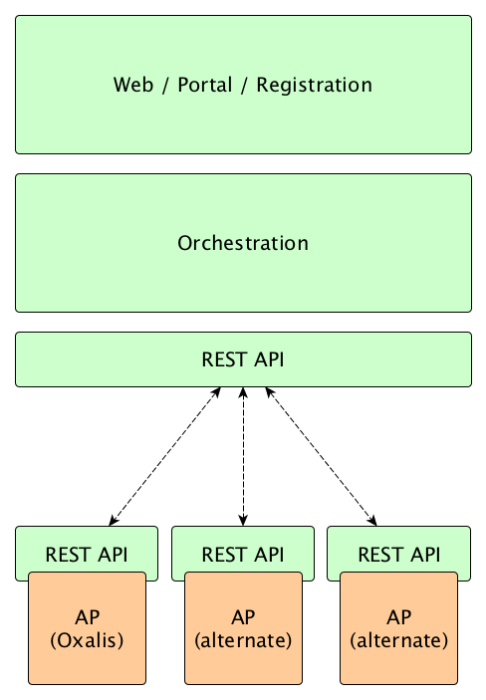

Figure 1 - Layers of the Testbed and orchestration with arbitrary AP implementations

    - REST API
The REST API should rely on an XSD with a set of well-defined supported actions that are communicated with XML. It is required for Approving AP implementations to implement this API.
Possible actions:
- Initiate transaction from AP
- Callback from sending AP (on outcome)
- Callback when AP receives transaction
- Callback when AP experiences a reception error

- Next step
To support an urgent need for implementation of a centralized e-delivery Testbed supporting both AS2 and AS4 implementations it is important for the Testbed implementation project to get verified that the listed requirements and high-level implementation strategy reflects the discussions between TICC and Operations, made during fall 2017 and spring 2018, and that the suggested implementation supports these requirements.
Should the TICC CMB not be able to approve the current version it is important that revision are made during or immediately after the meeting in order to ensure final approval as soon as possible (preferable within a week).
When approved:
- The TICC CMB requests the OpenPEPPOL Operations manager to ensure establishment of 3rd party hosting according to the listed requirements, and based on a suggestion from the team in Operations implementing the testbed.
- The Testbed implementation team develops v 1.0 of the Testbed and the API for connecting underlying AP’s.
- The Testbed implementation team develops guidance for implementing the API connecting approving AP’s with the Testbed front end.
- difi implements the API in the Oxalis AS2 and AS4 implementations
- The Testbed implementation team develops, in cooperation with Operations and the TICC CMB a standard agreement to be signed by the members volunteering to provide approving AP implementations
- The TICC Testbed work group is re-established in order to specify requirements, terms and conditions for the next version of the e-delivery Testbed functionality.
- The Testbed implementation team works closely with Operations in order to implement and deploy v 1.0 of the Testbed.
- The Testbed version 1.0 is handed over to Operations for further maintenance and operations

- Additional notes
Implementing the Testbed is time critical for a number of OpenPEPPOL activities, such as:
- CEF e-delivery convergence with OpenPEPPOL, a strategic collaboration with the EC CEF team enabling the use of the e-delivery AS4 profile in OpenPEPPOL. This project has a deadline by end of June for implementing OpenPEPPOL test facilities for e-delivery AS4 implementations.
- Onboarding of service providers from Singapore, it has been agreed that OpenPEPPOL provides test facility for onboarding of service providers from Singapore, and that the PA in Singapore provide the support team guiding these providers through the test.
Deadline end June 2018.
- Onboarding of service providers from Germany, it has been agreed that OpenPEPPOL provide test facility for onboarding of service providers from Germany.
Deadline end November 2018
- Direct support to onboarding of service Providers in Italy. – Italy intends to set up their test regime if OpenPEPPOL does not provide a country neutral test facility.
Deadline overrun….

